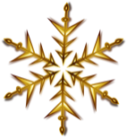

**All Saints’ Services in December 2024**

**Sunday 1st**

9.30am All Age

**Sunday 8th**

9.30am Holy Communion with Sunday Club

**Friday 13th**

3.20pm Christmas is Coming Trail  
 (meet at Methodist Church)

**Sunday 15th**

9.30am Holy Communion

3pm DIY Nativity and Tea

**Saturday 21st**

5.00pm Village Carol Service

**Sunday 22nd**

9.30am Holy Communion

**Tuesday 24th**

4.00pm Village Christingle

11.30pm Midnight Mass

**Wednesday 25th**

10am All Age Holy Communion

**Sunday 29th**

10.30am Holy Communion Team Service, Barton